Homework – Set: Wed 4th Feb Due In: Wed 11th Feb
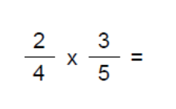 | 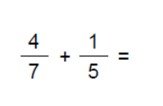
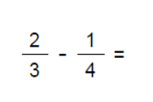 | 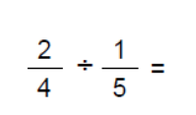
- Calculate the size of a single interior angle of a Regular Dodecagon. | - What is a single exterior angle for a regular pentagon?
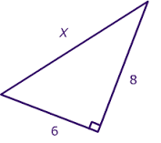  - Calculate the missing length | - Calculate the missing length
- Calculate the Surface Area of the Prism

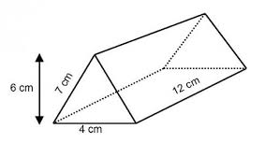

10 ) Calculate the Volume of the Prism

