Homework – Set: Wed 11th Feb Due In: Wed 25th Feb
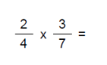 | 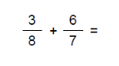
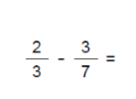 | 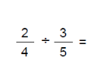
- Bisect the angle | - Calculate the area of this Parallelogram  7cm  5cm  12cm
- Calculate the area of this Trapezium  6 cm  7 cm  8 cm  5 cm | - Calculate the Surface area of this cuboid  3 cm  4 cm  10 cm
- Multiply out the brackets  - 3(2x + 7)  - 5x(x – 4)  - (x + 3) (x + 8) | - Factorise (put back into brackets)  - 8x - 22  - 3x² + 9x

