Homework – Set: Friday 6th^{th} March Due In: Fri 13th March
- If there are 800 boys and 5oo girls in a school and I want a stratified sample of 50 students.  How many boys and how many girls will I need to ask? | - Describe a way to do a random sample.
- The table and histogram below show the same data for the heights of 100 adults.
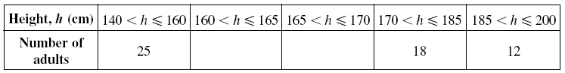
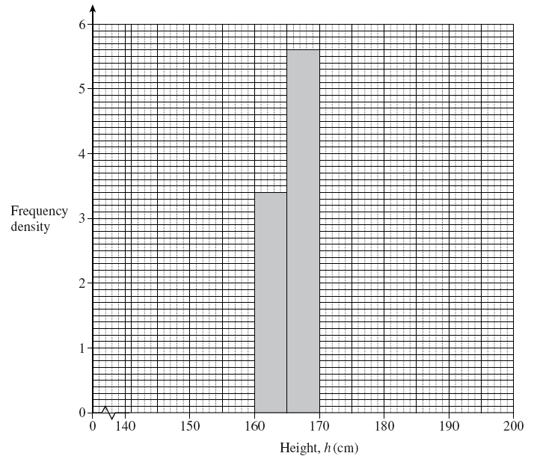
Complete the table and the histogram
[4 marks]

- Calculate the missing angles  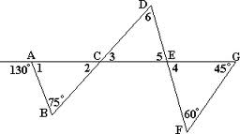 | - Calculate the value of a single interior angle of a regular heptagon.
- Multiply out the brackets  Example  - 5(x + 9) = 5x + 45  - 7x(x – 3) = 7x² – 21x  - (x + 2) (x + 5)  = x² + 5x + 2x + 10  = x² + 7x + 10 | - Multiply out the brackets  - 3(x – 8)  - 5x(x + 7)  - (x + 4)(x + 7)
- Solve the following equations:

- 3x = 27
- 5x + 9 = 24
- 3x + 7 = 5x – 1
- $\frac{2x+7}{3}=\frac{3x-12}{2}$

- Solve the following inequality draw the answer on the number line
5x + 8 = 8x - 1

