Homework – Set: Wed 11th Feb Due In: Fri 27th Feb
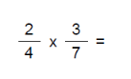 | 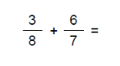
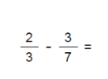 | 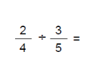
- Bisect the angle | - a) What is a sum of the interior angles for a regular pentagon?  - What is a single interior angle?
- Multiply out the brackets  - 3(2x + 7)  - 5x(x – 4)  - (x + 3) (x + 8) | - Factorise (put back into brackets)  - 8x - 22  - 3x² + 9x  - x² + 8x + 12
