Homework – Set: Wed 28th Jan Due In: Fri 6th Feb
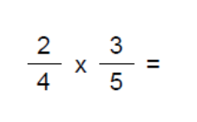 | 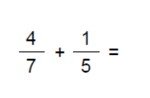
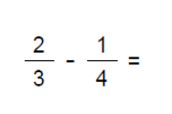 | 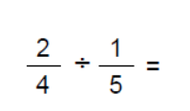
- Draw an angle of 37º | - What is a single exterior angle for a regular pentagon?
- Multiply out the brackets  - 5(x + 9)  - 7x(x – 3)  - (x + 2) (x + 5) | - Factorise (put back into brackets)  - 6x - 27  - 2x² + 14x  - x² + 7x + 12
- Put these numbers in an ordered stem and leaf diagram.

35, 67, 43, 59, 53, 31, 60, 45, 55, 39, 48, 53, 40, 49

- Work out the:
- Median
- Range
- Interquartile Range

