Check the data
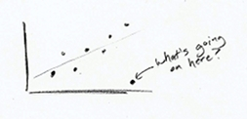
This should be obvious. Data forms the foundation of charts and graphs. If your data is weak, your graph is weak, so make sure it makes sense. Start with some simple graphs to see if there are any outliers or weird spikes. Verify anything that doesn't make sense. You might be surprised how many data entry typos you find in the spreadsheets people send you.

Explain encodings
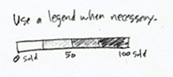
Maybe you use a colour scale to indicate magnitude or the size of a square to represent values. Maybe it's a combination of both. Explain what these encodings are supposed to indicate, and don't assume the reader knows what everything means. Most likely he doesn't.
You can provide explanations in a variety of ways, but the most common are providing a legend, directly labeling shapes, or describing your graphic in a lead-in paragraph.
Without your pointers, it's a guessing game for the reader.

Label axes
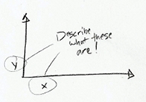
Oh look, what fine gridlines you have there. Without labels or any explanation, they're just decoration. Label your axes so that readers know what scale points are plotted on. Is it logarithmic, incremental, exponential, or per 100 flushing toilets? Without axis labels, I always assume it's that last one. Also, in most cases, you'll want your value axis to start at zero.

Include units
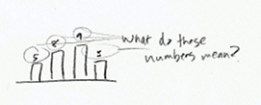
Include some units while you're at it. If you just leave it with naked numbers, it could mean anything from a percentage, to a volume, to the number of chickens that crossed the road. Again, you want to eliminate the need for any guesswork from the reader.

Include your sources
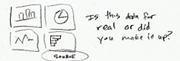
This should go without saying. Always include where the data is from. You can put it directly in a graphic, or if it's part of an article, the source can be specified in the copy. This does a couple of things. First, it makes your graphic more reputable, and second, those who are interested can dig deeper or fact check.

Consider your audience
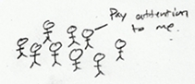
Finally, like I said already, take into account who and what your graphs and charts are for, and design accordingly. You might design a graphic to be super-detailed for a poster that people can stare at for hours. But if it's for a presentation, you should keep the words to a minimum.
( taken from http://flowingdata.com/2010/07/22/7-basic-rules-for-making-charts-and-graphs/ )

