Fractions
Equivalent Fractions
Equivalent fractions are fractions that are the same size but use different values within the fraction.
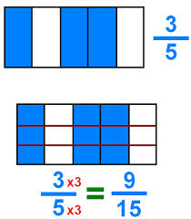
For example:

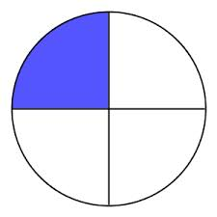
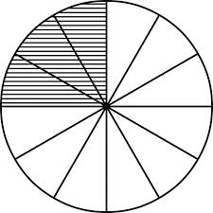
Just as: $\frac{3}{12}=\frac{1}{4}$

Improper Fractions
We also have to recognise Top Heavy or Improper fractions
e.g. $\frac{7}{4}$This is equal to $1\frac{3}{4}$ because $\frac{4}{4}$
make a whole 1 then there are 3 left from the 7 which are still quarters.

This works the other way too: 1$\frac{2}{3}=\frac{5}{3}$
As the whole 1 is the same as $\frac{3}{3}$ plus the extra $\frac{2}{3}$gives us $\frac{5}{3}$

Adding fractions
To add fractions we must have the same number as the Denominator (Bottom Number)

e.g. $\frac{1}{5}+\frac{2}{5}= \frac{3}{5}$

So if we have
$$\frac{1}{3} +\frac{1}{6}$$
We need to change the denominator so that we have the same.
Luckily 3 goes into 6 so we only have to change one of the fractions. This is where Equivalent fractions come in....
$$\frac{1}{3}=\frac{2}{6}$$
So the question now becomes......
$\frac{2}{6} +\frac{1}{6}= \frac{3}{6}$ which we can then simplify to ½

When the denominators do not work nicely like this we have to change both of them......

e.g.
$$\frac{1}{3} +\frac{2}{5}$$
We need to change the denominator so that we have the same.
This is where Equivalent fractions come in again....
$\frac{1}{3}=\frac{2}{6}=\frac{3}{9}=\frac{4}{12}= \frac{5}{15}$ and $\frac{2}{5}=\frac{4}{10}= \frac{6}{15}$
As we need the denominator the same we have to go for the denominator that both 3 and 5 go into! Yep – you guessed it... 15
So the question now becomes......
$\frac{5}{15} +\frac{6}{15}= \frac{11}{15}$ and we are done!

Subtraction works EXACTLY the same!! You just take the numbers away at the end!
e.g. $\frac{5}{6}- \frac{1}{4}$
$$=\frac{10}{12}-\frac{3}{12}=\frac{7}{12}$$

Multiplying Fractions
To multiply fractions we simply multiply the numerator with the numerator and the denominator with the denominator.
A rhyme to remember it....
“Top with Top,
Bottom with Bottom,
Times them both,
Or you’re Rotten!”

e.g. $\frac{3}{4}×\frac{2}{5}= \frac{3×2}{4×5}= \frac{6}{20}$ which we can then simplify to $\frac{3}{10}$

Dividing Fractions
To divide fractions we also have a nice, simple rule... if you can remember it....
COPY....... CHANGE....... FLIP

e.g. $\frac{2}{3}÷\frac{1}{4}$
so as the rule says.....
Copy the 1st Fraction... Change the sign to the opposite... Flip the 2nd fraction
$\frac{2}{3}$ x $\frac{4}{1}$

We now have the multiplication $\frac{2}{3}×\frac{4}{1}= \frac{2×4}{3×1}=\frac{8}{3}$

